USAFILINK: A PROXIMITY-BASED EXHAUSTER SERVICE MANAGEMENT SYSTEM

Clive Misiko Mutende
Supervisor: Charles Mwabu

A proposal submitted to the Department of Information Technology in the School of Computing and Information Technology in partial fulfillment of the requirements for the award of the Degree of Bachelor of Science in Information Technology, Jomo Kenyatta University of Agriculture and Technology.

2026

DECLARATION
This proposal is my original work and has not been presented for a degree in any other University.

Signature: _________________ Date: _________________

This proposal has been submitted for examination with my approval as University Supervisor.

Signature: _________________ Date: _________________

ABSTRACT
Urban population growth in Kenya has intensified dependence on septic systems across residential estates, apartments, and commercial premises. Despite the critical role of exhauster services in maintaining sanitation and public health, the current service delivery model remains informal, fragmented, and spatially inefficient. Customers struggle to identify the nearest available exhauster service provider in real time, while drivers face challenges in optimised routing, scheduling, and payment collection. These inefficiencies lead to prolonged response times, customer dissatisfaction, and unnecessary environmental risks.
This research proposes the design and development of UsafiLink, a proximity-based exhauster service management system that automatically matches customers to the nearest available exhauster truck using real-time GPS coordinates and geospatial algorithms. The system will enable customers to submit service requests via a mobile application, receive automated dispatch of the nearest driver, view live tracking of the assigned truck, and complete payments through M-Pesa integration. Drivers will receive optimised navigation routes and booking schedules, while administrators will monitor operations through a web-based dashboard.
The study will adopt an Agile System Development Methodology and will investigate the effectiveness of proximity-based dispatch algorithms in reducing customer wait times and improving route efficiency. The expected outcome is a scalable, transparent, and responsive digital platform that modernises sanitation service delivery within the Kenyan urban context.

Table of Contents
DECLARATION 2
List of Figures 7
List of Tables 8
ACRONYMS 9
DEFINITION OF TERMS 10
CHAPTER ONE: INTRODUCTION 11
1.1 Background 11
1.2 Project Overview 11
1.3 Statement of the Problem 12
1.4 Proposed Solution 13
1.5 Objectives 14
1.6 Research Questions 14
1.7 Justification 14
1.8 Proposed Research and System Methodologies 15
1.9 Scope 16
CHAPTER TWO: LITERATURE REVIEW 17
2.1 Introduction 17
2.2 Theoretical Review 17
2.3 Case Study Review 18
2.4 Integration and Architecture 19
2.5 Summary 20
2.6 Research Gaps 20
CHAPTER THREE: SYSTEM ANALYSIS AND DESIGN 23
3.1 Introduction. 23
3.2 System Development Methodology. 23
3.2.1 Advantages of Agile Methodology 24
3.3 Feasibility Study. 24
3.3.1 Technical Feasibility 24
3.3.2 Economic Feasibility 25
3.3.3 Legal Feasibility 26
3.3.4 Operational Feasibility 26
3.3.5 Social Feasibility 26
3.3.6 Conclusion of the Feasibility Study 27
3.4 Requirements Elicitation 28
3.4.1 Data Collection Methods 28
3.4.2 Sampling Techniques 28
3.4.3 Sample Size Determination 29
3.4.4 Relevance of Collected Data to the Research 29
3.4.5 Conclusion 29
3.5 Data Analysis 30
3.5.1 Analysis of Interview Responses 36
3.5.2 Analysis of Questionnaire Responses 36
3.5.3 Acceptance of the Proposed System. All five customer respondents and all three driver respondents expressed willingness to use a web-based exhauster service management system. Drivers prioritised digital payment collection and route efficiency tools, while customers emphasised transparent pricing and real-time driver tracking. 36
3.5.4 Conclusion 36
3.6 System Specification 37
3.6.1 Functional Requirements 37
3.6.2 Development Methodology Diagrams 38
3.6.2 Non-Functional Requirements 40
3.6.3 System Users 41
3.6.4 Conclusion 41
3.7 Requirements Analysis and Modelling 42
3.7.1 Requirements Analysis 42
3.7.2 Requirements Structuring 42
3.7.3 Requirements Modelling 43
3.8 Logical Design 47
3.8.1 System Architecture 47
3.8.2 Control Flow and Process Design 47
3.8.3 Structured English Description of Haversine Dispatch Algorithm: 47
3.8.4 Control Flow and Process Design 48
3.8.5 Design of Non-Functional Requirements 50
3.9 Physical Design 51
3.9.1 Database Design 51

List of Figures
Figure 1Agile Methodology Phases – UsafiLink 23
Figure 2 Biggest challenge with current services 29
Figure 3Feature usefulness ratings and main system concerns. 30
Figure 4Main concern about the proposed system. 30
Figure 5M-Pesa usage and driver booking management methods. 31
Figure 6Current booking management methods; most useful features for drivers 32
Figure 7driver perception of UsafiLink’s impact on service efficiency. 33
Figure 8UsafiLink Project Gantt Chart (M1–M8 = Months 1–8) 36
Figure 9: Use Case Diagram – UsafiLink 39
Figure 10: Context Diagram (Level 0 DFD) – UsafiLink 40
Figure 11Class Diagram – UsafiLink Core Entity Classes 41
Figure 12UsafiLink Three-Tier Client-Server Architecture Diagram 42
Figure 13Flow-chart Diagram – Haversine Proximity Dispatch Algorithm 44
Figure 14Entity Relationship Diagram (ERD) – UsafiLink 46
Figure 3.14 Illustration of the UsafiLink Login Page 50
Figure 3.15 Illustration of the Customer Dashboard 51
Figure 3.16 Illustration of the New Booking Form with Price Estimate 52
Figure 3.18 Illustration of the Admin Dashboard 54

List of Tables
Table 1Cost-Benefit Evaluation – UsafiLink 24
Table 2: Summary of Key Findings from Requirements Elicitation 28
Table 3Functional Requirements – UsafiLink 35
Table 4: UsafiLink Scrum Sprint Schedule 35
Table 5: Logical Database Structure – Users Table 47
Table 6Logical Database Structure – Drivers Table 48
Table 7Logical Database Structure – Jobs Table 48
Table 8: Logical Database Structure – Payments Table 49

ACRONYMS
API – Application Programming Interface
GPS – Global Positioning System
GIS – Geographic Information System
JKUAT – Jomo Kenyatta University of Agriculture and Technology
M-Pesa – Mobile Pesa (Mobile Money Platform by Safaricom)
OTP – One-Time Password
REST – Representational State Transfer
SMS – Short Message Service
UI – User Interface
UX – User Experience

DEFINITION OF TERMS
Exhauster Service: A sanitation service that involves the pumping and removal of accumulated waste from septic tanks and pit latrines using specialised vacuum trucks.
Geospatial Proximity Matching: The computational process of calculating the physical distance between a customer's GPS coordinates and available service providers to identify and dispatch the nearest one automatically.
Nearest-Neighbour Algorithm: A greedy optimisation algorithm that selects the closest available resource to a given point, used in this system to identify the nearest exhauster truck to a service request.
Real-Time Tracking: The continuous monitoring and display of a moving vehicle's GPS position on a digital map as it changes over time.
Septic Tank: An underground chamber made of concrete or plastic through which domestic wastewater flows for basic sewage treatment.
M-Pesa: A mobile phone-based money transfer and payment service operated by Safaricom, widely used in Kenya for digital financial transactions.
Agile Methodology: An iterative software development approach that emphasises collaboration, flexibility, and incremental delivery of functional software through repeated development cycles known as sprints.

CHAPTER ONE: INTRODUCTION

1.1 Background
Globally, rapid urbanisation has accelerated the demand for reliable and efficient sanitation services, particularly in developing regions where centralised sewer infrastructure is limited or non-existent. According to the United Nations (2023), over 55% of the world's population now lives in urban areas, with that figure projected to reach 68% by 2050. This urban density places immense pressure on on-site sanitation systems, particularly septic tanks, which require regular emptying by exhauster trucks. In technologically advanced economies, platforms leveraging real-time GPS tracking, automated dispatch, and proximity-based matching have already transformed service industries such as transportation, food delivery, and emergency response, demonstrating the operational gains achievable through digital spatial intelligence.
In Sub-Saharan Africa, and specifically Kenya, the sanitation challenge is acute. The Kenya National Bureau of Statistics (2022) estimates that over 40% of urban households in cities such as Nairobi, Kiambu, Machakos, and Mombasa depend on septic systems. Exhauster services in these cities are predominantly offered by private operators who coordinate jobs manually through phone calls and informal word-of-mouth referrals. This approach produces systemic inefficiencies including delayed response times, poor spatial routing, inconsistent pricing, and limited accountability. The growing penetration of smartphones, mobile internet, and mobile payment platforms such as M-Pesa presents a concrete opportunity to digitally transform how exhauster services are accessed, dispatched, and managed. The critical gap lies in the absence of a location-aware platform that can automatically identify and dispatch the nearest available exhauster to a customer in need.

1.2 Project Overview
This research falls within the domain of **proximity-based geospatial service dispatch systems**, an application of location-based information systems that uses real-time GPS data and distance computation algorithms to automatically match service requesters to the nearest available service provider. Specifically, the study applies this paradigm to the sanitation sector through the design and development of UsafiLink, a platform that connects customers requiring exhauster services (septic tank emptying) with the nearest available exhauster truck using the Haversine nearest-neighbour algorithm. The research integrates mobile and web technologies, real-time GPS tracking, and M-Pesa payment infrastructure to address the spatial inefficiencies, prolonged response times, and lack of payment transparency that characterize the current informal exhauster service coordination model in Kenyan urban areas. This field has seen significant global adoption in domains such as ride-hailing (Uber, Bolt), emergency medical services, and on-demand delivery. The core computational principles underpinning this research include geospatial distance computation, nearest-neighbour dispatch algorithms, real-time data synchronisation, and mobile payment API integration.
Globally, systems such as Uber's dispatch engine use variants of the nearest-neighbour and Hungarian assignment algorithms to minimise wait times and improve fleet utilisation. Regionally, platforms like Little Cab and Sendy in Kenya have demonstrated that these principles are transferable to the East African context given adequate mobile infrastructure. However, within the sanitation services sector, no equivalent proximity-aware platform exists in Kenya or the broader East African region. UsafiLink seeks to bridge this technological gap by applying proven geospatial dispatch principles to the exhauster service domain. The system will integrate mobile applications, a web-based administration panel, GPS mapping services, and M-Pesa mobile payments to deliver an end-to-end digital sanitation service solution.

1.3 Statement of the Problem
Despite the essential role of exhauster services in maintaining public health and environmental safety in Kenyan urban areas, the prevailing service delivery model is spatially unintelligent, inefficient, and poorly coordinated. The most critical operational failure is the absence of proximity-based matching: when a customer requires exhauster services, there is no mechanism to automatically identify or dispatch the nearest available driver. Instead, customers must make multiple phone calls, rely on personal referrals, or wait indefinitely for a driver who may be located far away, while a closer driver remains unaware of the request. This spatial mismatch is the root cause of excessive response times and underutilisation of available driver capacity.
Exhauster drivers are equally disadvantaged by the current model. The lack of centralised, location-aware job management means that drivers often travel suboptimal routes, encounter overlapping bookings, and spend significant time and fuel on unnecessary travel. Manual payment collection introduces additional risks including disputes, unpaid services, and lack of financial record keeping. The Kenya National Environment Management Authority (2021) has cited delayed septic emptying as a contributing factor to groundwater contamination incidents in peri-urban Nairobi, illustrating that service delays are not merely inconvenient but carry tangible environmental and public health consequences.
The absence of a geospatially-aware digital platform tailored to exhauster service management results in prolonged customer wait times, driver route inefficiency, revenue loss for service companies, and environmental risk. The problem is compounded by rising urban demand and the complete absence of any proximity-based dispatch mechanism within the sector.

1.4 Proposed Solution
This research proposes the design and development of UsafiLink, a proximity-based exhauster service management system that automatically matches customers to the nearest available exhauster truck using real-time GPS coordinates and geospatial distance computation. The system will implement a nearest-neighbour dispatch algorithm that calculates the Haversine distance between a customer's submitted GPS coordinates and all active exhauster drivers registered on the platform, selecting and notifying the closest available driver in real time. The research component will investigate the effectiveness of this proximity-based dispatch approach in minimising customer wait times and improving overall route efficiency compared to the existing manual coordination model.
The customer-facing mobile application will allow users to submit service requests with automatic GPS location capture, view the assigned driver's live location on an interactive map, receive estimated arrival times derived from distance and traffic data, and complete payments securely via M-Pesa. Exhauster drivers will receive push notifications for new nearby jobs, turn-by-turn navigation to customer locations, consolidated booking schedules, and digital payment confirmations. An administrative web dashboard will enable service companies to monitor driver locations, manage job assignments, track operational performance metrics, and generate service reports. The proposed system does not merely digitise existing manual processes; it introduces spatial intelligence and automated proximity matching as fundamentally new capabilities that do not exist in the current model.

1.5 Objectives
General Objective
To design and develop a proximity-based exhauster service management system that uses real-time GPS matching to connect customers with the nearest available exhauster driver.

Specific Objectives
- To analyse the operational challenges and spatial inefficiencies within existing exhauster service delivery processes in selected Kenyan urban areas.
- To design and implement a geospatial proximity-matching algorithm that dispatches the nearest available exhauster driver to a customer's GPS location in real time.
- To integrate a secure M-Pesa payment module via the IntaSend API within the mobile and web platform to support transparent and verifiable service transactions.
- To evaluate the system's effectiveness in reducing customer wait times and improving driver route efficiency through usability and performance testing.

1.6 Research Questions
- What spatial and operational challenges most significantly undermine the efficiency of exhauster service delivery in Kenyan urban areas?
- How effectively does a proximity-based geospatial dispatch algorithm reduce customer wait times compared to the existing manual coordination model?
- In what ways does digital payment integration through M-Pesa enhance financial transparency and accountability in exhauster service transactions?
- To what extent does the proposed system improve overall operational efficiency and user satisfaction for both customers and exhauster drivers?

1.7 Justification
Efficient sanitation services are foundational to public health, environmental protection, and the sustainability of Kenyan urban settlements. This research is justified by the significant and demonstrable inefficiencies of the current exhauster service model, particularly the absence of any proximity-aware dispatch mechanism that could reduce response times and improve spatial efficiency. By introducing automated GPS-based matching as the system's core function, UsafiLink addresses a gap that existing digital platforms in Kenya have not yet targeted within the sanitation domain.
The research benefits multiple stakeholders. Customers in urban Kenya will gain access to a faster, traceable, and transparently priced service that reduces the health risks associated with delayed septic emptying. Exhauster drivers and service companies will benefit from optimised job routing, reduced fuel costs, improved scheduling, and a verifiable digital payment trail. At a broader level, reduced response times decrease the likelihood of septic overflow events that contribute to waterborne disease outbreaks and groundwater contamination.
Academically, this research contributes to the growing body of knowledge on proximity-based geospatial dispatch systems within service domains that have received limited technological attention in the Global South. It specifically investigates the applicability and performance of nearest-neighbour algorithms in a sanitation services context, providing empirical data on algorithm efficiency and user adoption in a Kenyan urban setting. This fills a clear research gap and establishes a methodological foundation for future smart sanitation service research in the region.

1.8 Proposed Research and System Methodologies
The project will adopt an Agile System Development Methodology, structured around iterative two-week sprints. Agile is selected because the system involves multiple interdependent components including the mobile application, the geospatial dispatch engine, and the payment integration module, each of which benefits from incremental development and continuous testing with real users. The iterative nature of Agile allows proximity algorithm performance to be tested and refined across successive sprints based on empirical results. Authentication is managed through Clerk (supporting Google OAuth, email/password, and magic links), while Africa's Talking API handles SMS notifications for driver dispatch alerts and customer confirmations.
The research methodology will involve a mixed-methods approach. Quantitative data will be collected through structured questionnaires administered to exhauster service operators and customers to document existing response time benchmarks and operational pain points. The proximity-matching algorithm's performance will be evaluated by measuring dispatch response times, driver travel distances, and system accuracy under simulated and live conditions. Qualitative data will be gathered through semi-structured interviews with drivers and service company administrators.System development will employ React.js with Vite for frontend development, styled via TailwindCSS, Django and Django REST Framework (DRF) for the backend API, SQLite3 for local database storage, Celery for executing asynchronous background tasks (scheduling, polling), Google Maps Platform for geolocation and routing services, IntaSend API (which integrates Safaricom's M-Pesa STK Push for customer payments and B2C driver payouts), and Africa's Talking API for SMS notifications.

1.9 Scope
This study is limited to the design, development, and evaluation of the UsafiLink system within selected urban areas in Kenya, specifically Kiambu County (including the towns of Juja, Ruiru, and Kimbo) and its peri-urban zones where septic systems are prevalent and exhauster services are in high demand. The system will focus on connecting individual customers, registered exhauster drivers, and service companies through mobile and web-based interfaces centred on proximity-based GPS matching. The study will not address physical waste treatment processes, government sewer infrastructure management, or regulatory frameworks governing waste disposal.
The proximity-based dispatch algorithm will be evaluated using simulated GPS data and a pilot deployment with a small cohort of registered drivers and test users. Generalisability of findings may be limited by the small sample size inherent in a final-year project. Additional constraints include dependence on consistent internet and GPS connectivity for system functionality, availability of GPS-enabled smartphones among drivers, and access to real operational data from exhauster service companies. The research will confine itself to functional, usability, and performance evaluation within these defined parameters.

CHAPTER TWO: LITERATURE REVIEW

2.1 Introduction
This chapter reviews existing literature relevant to the design and development of UsafiLink, a proximity-based exhauster service management system. The chapter is organised around the key research area of geospatial proximity-based service dispatch, with specific attention to its application in on-demand service platforms. It explores the theoretical foundations underpinning proximity matching algorithms, surveys case studies of similar systems deployed globally and regionally, examines architectural and integration approaches, and concludes with a summary of research gaps that this study seeks to address. The review draws from peer-reviewed literature published predominantly within the last five years to ensure relevance to current technological capabilities.

2.2 Theoretical Review
Proximity-based service dispatch is grounded in the principles of computational geometry and spatial algorithms. The most fundamental concept is geodesic distance computation, specifically the Haversine formula, which calculates the great-circle distance between two points on the Earth's surface given their latitude and longitude coordinates (Chopde & Nichat, 2013). This formula is widely used in location-based services because it accounts for the curvature of the Earth and provides accurate distance estimates at the scale of urban service areas. In UsafiLink, the Haversine formula forms the basis of the proximity-matching module that computes distances between a customer's GPS coordinates and all active driver locations.
Building on geodesic distance computation, the nearest-neighbour algorithm represents the most commonly applied dispatch strategy in on-demand service platforms. The algorithm selects the resource, in this case an exhauster driver, with the smallest computed distance to the requesting customer. While computationally simple with O(n) time complexity relative to the number of active drivers, the nearest-neighbour approach has well-documented limitations: it is a greedy algorithm that optimises locally without considering global fleet efficiency, and in high-demand scenarios it can lead to the over-utilisation of drivers clustered near request hotspots while distant drivers remain idle (Psaraftis et al., 2016). More advanced alternatives include the Hungarian algorithm for optimal one-to-one bipartite matching and genetic algorithms for multi-objective route optimisation, though these carry significantly higher computational costs that may be disproportionate for a platform of UsafiLink's initial scale.
A complementary theoretical framework is the Technology Acceptance Model (TAM), proposed by Davis (1989), which posits that user adoption of a technology is primarily determined by perceived usefulness and perceived ease of use. For UsafiLink, TAM provides a theoretical basis for evaluating whether customers and drivers will adopt the platform and whether the proximity-matching feature is perceived as a meaningful improvement over the current manual model. TAM has been widely applied in studies of mobile service adoption in Sub-Saharan Africa (Lwoga & Lwoga, 2017), lending direct relevance to the Kenyan context of this research.

2.3 Case Study Review
The most globally prominent application of proximity-based dispatch is found in ride-hailing platforms. Uber's dispatch system, extensively documented by Ghoseiri and Ghannadpour (2020), employs a weighted nearest-neighbour matching enhanced with demand forecasting models. The system considers not only current driver distance but also predicted future demand hotspots, achieving mean passenger wait times of under three minutes in dense urban markets. Critically, Uber's experience demonstrates that even a basic nearest-neighbour implementation produces substantial improvements over manual dispatch, with a reported 40% reduction in average wait time compared to traditional taxi coordination. This empirical precedent directly supports the hypothesis underlying UsafiLink's research component.
In the African context, Little Cab, a Kenyan ride-hailing platform launched in 2016, demonstrates the successful localisation of proximity-based dispatch technology. Little Cab integrates M-Pesa payments natively and operates effectively within Nairobi's patchy internet connectivity environment by implementing offline request queuing (Little Cab, 2022). Its success confirms that geospatial dispatch models are technically and commercially viable in the Kenyan mobile infrastructure environment, a conclusion directly relevant to UsafiLink's deployment context.
Within the sanitation domain specifically, the iWASH platform piloted in Uganda by IRC and Akvo (2021) provides the most relevant regional case study. iWASH enabled digital service requests and GPS-based tracking for pit latrine emptying services in Kampala using a web application accessible on feature phones. The platform reported a 35% reduction in average service response time and a significant improvement in driver route efficiency. However, iWASH did not implement automated proximity-based dispatch; service operators manually reviewed and assigned requests. This represents a direct precursor to UsafiLink's more automated approach and confirms the demand for such services while identifying the automation gap that this research addresses.

2.4 Integration and Architecture
Location-based service systems of the type proposed for UsafiLink typically follow a client-server architecture with a RESTful API middleware layer. While many existing platforms utilise Node.js backends with PostgreSQL databases, UsafiLink will employ Django and Django REST Framework for the backend API, with SQLite3 as the relational database. The frontend will be built using React.js configured with Vite and styled via TailwindCSS. The backend processes proximity computations, manages the database, and interfaces with third-party services including the Google Maps Platform API for geocoding and routing, the Safaricom Daraja API for M-Pesa payment processing, and Celery for executing asynchronous background tasks such as scheduling and polling. This architecture is well-documented and widely adopted in on-demand service platforms (Fielding, 2000; Google, 2023).
For real-time driver location updates and live tracking, WebSocket connections provide a more efficient alternative to repeated HTTP polling. WebSocket protocols maintain persistent bidirectional connections between the driver's mobile application and the server, enabling location updates at configurable intervals (typically every five seconds) with minimal latency and bandwidth overhead. Firebase Realtime Database has emerged as a popular managed alternative that simplifies real-time data synchronisation in mobile applications without requiring custom WebSocket server infrastructure (Moroney, 2017), and is a candidate technology for UsafiLink's live tracking module.
The PostGIS extension for PostgreSQL enables server-side geospatial computations using the ST_Distance and ST_DWithin functions, which can efficiently query all drivers within a specified radius of a customer's coordinates using spatial indexing. This approach is significantly more scalable than computing distances in application code, as PostGIS leverages R-tree spatial indices to achieve sub-linear query times even with large driver datasets (Obe & Hsu, 2015). For M-Pesa integration, the Safaricom Daraja API's STK Push functionality allows the server to initiate a payment prompt directly on the customer's phone, supporting a seamless in-app payment experience without requiring customers to leave the application.

2.5 Summary
The literature reviewed confirms several key findings relevant to UsafiLink. First, proximity-based nearest-neighbour dispatch is a well-validated approach for reducing service wait times in on-demand platforms, with empirical reductions of 35 to 40% documented in both global and regional deployments. Second, the technology is transferable to the Kenyan urban context, as demonstrated by Little Cab's successful localisation of GPS dispatch with M-Pesa integration. Third, while digital platforms have been introduced to sanitation services in East Africa through initiatives like iWASH in Uganda, none have implemented automated proximity-based dispatch, confirming the novelty of UsafiLink's core contribution. Fourth, the technical architecture combining RESTful APIs, PostGIS spatial queries, real-time WebSocket or Firebase communication, and M-Pesa Daraja integration represents a proven and well-documented implementation pathway.

2.6 Research Gaps
The literature review reveals two substantive research gaps that UsafiLink seeks to address. The first and primary gap is the absence of any empirically evaluated proximity-based dispatch system applied specifically to exhauster and sanitation services. While nearest-neighbour dispatch has been extensively studied in ride-hailing and emergency services, no published research has measured its effectiveness in the context of exhauster service coordination in Sub-Saharan Africa. UsafiLink will generate original empirical data on the impact of proximity-based automated dispatch on customer wait times and driver route efficiency within this domain.
The second gap concerns the integration of mobile payment systems within location-based sanitation service platforms in the Kenyan context. Existing sanitation digital tools in East Africa have not incorporated M-Pesa payment integration alongside real-time GPS tracking and automated dispatch in a single platform. UsafiLink addresses this gap by providing an integrated solution and evaluating the impact of digital payment transparency on customer trust and service accountability. Together, these gaps position UsafiLink as a novel academic contribution to both the geospatial information systems and digital sanitation services literature.

CHAPTER THREE: SYSTEM ANALYSIS AND DESIGN

3.1 Introduction.
This chapter presents the system analysis and design of UsafiLink, a proximity-based exhauster service management system. It is an overview of how the system is structured, designed and prepared for implementation. The chapter also outlines the methodologies, tools and techniques used in developing the system to ensure they meet functional and non-functional requirements.
Furthermore, the chapter examines the process of user requirements elicitation, designing system architecture, and modelling system components. It highlights how the integration of a Haversine proximity dispatch algorithm and M-Pesa payment infrastructure enhances efficiency, transparency and accessibility of exhauster service management. This chapter therefore serves as the blueprint for the implementation of the project.

3.2 System Development Methodology.
UsafiLink was developed using the Agile System Development Methodology, specifically the Scrum framework. Agile was selected because the system involves multiple interdependent components — the React and Vite web application frontend, the Django REST Framework backend, the SQLite development database, the Celery asynchronous task queue, and third-party API integrations including IntaSend for payments, Africa's Talking for SMS notifications, and GoogleAuth for authentication — each of which benefits from incremental development, continuous testing, and iterative refinement based on user feedback.
The development was organised into two-week sprints, each producing a working and testable increment of the system. The Agile methodology encompasses the following iterative phases:
- Requirements – identifying and defining the system's functionalities through stakeholder engagement with an exhauster driver and customers.
- Plan – organising gathered requirements into sprints, setting objectives, and estimating time and resources needed for each cycle.
- Design – creating the system architecture and design specifications including database structure, user interfaces, and the proximity dispatch module.
- Development – divided into five sprints each focusing on specific features: authentication, GPS dispatch, M-Pesa integration, dashboards, and testing.
- Release – deploying working increments to stakeholders for evaluation and feedback at the end of each sprint.
- Track and monitor – continuously observing system performance, collecting feedback and identifying improvements.
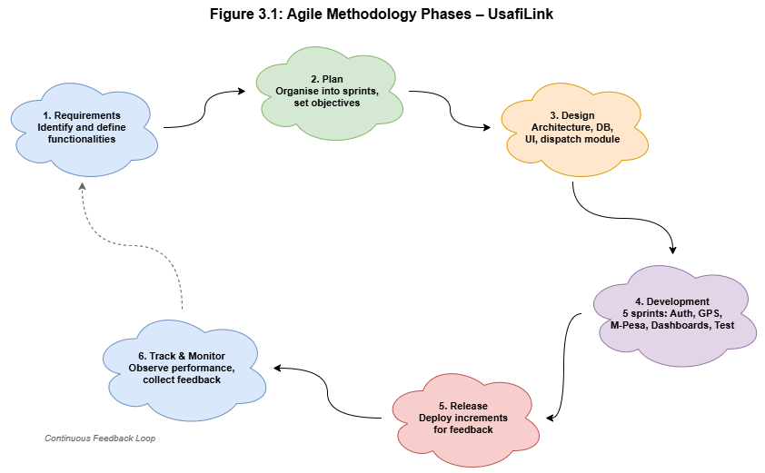
Figure 1Agile Methodology Phases – UsafiLink

3.2.1 Advantages of Agile Methodology
- Adaptability – when new requirements emerge (e.g., changes to the Haversine dispatch algorithm based on testing), they can be incorporated without disrupting overall development.
- Agile promotes continuous testing – ensuring errors are identified and resolved early, guaranteeing the reliability and security of the proximity dispatch and payment modules.
In summary, Agile provides a flexible, efficient, and user-centered approach to developing UsafiLink, ensuring a quality system and successful project delivery.

3.3 Feasibility Study.
A feasibility study was conducted to assess the viability of UsafiLink across five dimensions: technical, economic, legal, operational, and social feasibility. The aim was to determine whether the system is practical and achievable within the constraints of an eight-month development timeline and the available resources.

3.3.1 Technical Feasibility
Technical feasibility assesses whether the required technology and resources are available to successfully develop and implement the system. UsafiLink utilises the following modern, well-documented, and freely available technologies: React and Vite for the Progressive Web Application frontend, Django and Django REST Framework for the backend API, and SQLite for development with PostgreSQL for production deployment. External services handle critical infrastructure: IntaSend manages M-Pesa STK Push payments and driver B2C payouts; Africa's Talking powers SMS dispatches; Clerk and Google Auth manage identity verification; and Celery with Redis handles asynchronous task management including the ten-second driver timeout. All technologies are compatible and integration is achievable.

3.3.2 Economic Feasibility
Economic feasibility evaluates whether UsafiLink is financially viable by comparing initial costs against the expected benefits.
Initial Costs:
- Development costs – include hardware (computers and internet access), open-source software (Django, React, Celery, PostgreSQL carry no licence fees), and developer time.
- Operational costs – recurring costs after deployment include cloud hosting, Africa's Talking SMS charges per message, and IntaSend transaction fees per payment.
- Training costs – minimal, as the interface is designed for users with basic smartphone literacy.

Expected Benefits:
- Faster service coordination – eliminates phone-based booking delays, reducing average customer wait times.
- Digital payments – removes cash handling risks through M-Pesa integration.
- Transparent pricing – distance-based fare estimation eliminates pricing disputes.

Type of Cost | Nature | Impact
Development | One-time | Moderate
Operational (hosting, SMS, API fees) | Recurring | Low to Moderate
Expected Benefits (efficiency, adoption) | Long-term | High
Table 1Cost-Benefit Evaluation – UsafiLink
This means the system will provide a positive return on investment (ROI) over a short period; therefore, it is economically feasible.

3.3.3 Legal Feasibility
Legal feasibility assesses whether UsafiLink complies with relevant laws, regulations and policies governing data usage, privacy and digital transactions in Kenya. The system adheres to data protection principles by ensuring sensitive user information — including GPS coordinates, phone numbers and M-Pesa transaction records — is securely stored and accessible only to authorised parties. HTTPS, JWT authentication and PBKDF2/bcrypt password hashing protect data integrity. IntaSend payment callbacks are validated through IP whitelisting and payload signature verification to prevent unauthorised financial transactions. The system is legally feasible as it complies with applicable data protection and security requirements.

3.3.4 Operational Feasibility
Operational feasibility examines how well UsafiLink will function within its intended environment. The target users — an exhauster driver and customers in peri-urban towns in Kiambu County — demonstrate high rates of smartphone ownership and mobile internet usage. M-Pesa is embedded in daily financial transactions, reducing adoption barriers. The decision to implement UsafiLink as a responsive Progressive Web Application (PWA) rather than a native Android application is operationally appropriate given the storage space and data cost considerations of the target population. The system is therefore operationally feasible within the defined deployment context.

3.3.5 Social Feasibility
UsafiLink is socially feasible as it is user-friendly, accessible and directly addresses key challenges faced by exhauster service users: unclear pricing, service delays, and cash-only payments. It enhances trust and transparency among drivers, customers, and service administrators. Although there may be initial resistance due to unfamiliarity with digital service platforms, the minimal three-tap driver interface and familiar M-Pesa payment flow will promote acceptance. The system is expected to be widely adopted and beneficial to the target communities.

3.3.6 Conclusion of the Feasibility Study
Based on the feasibility analysis conducted, UsafiLink is feasible across all five dimensions. The system is practical and achievable; therefore the project is suitable for development and successful implementation.

3.4 Requirements Elicitation
Requirements elicitation is the process of gathering and analysing information from stakeholders to understand the needs and expectations for the proposed system. For UsafiLink, data was collected from actively operating an exhauster driver and customers in Nairobi and its peri-urban zones. The main purpose of data collection was to identify the challenges faced in the current exhauster service coordination process and to derive the requirements for the UsafiLink system.

3.4.1 Data Collection Methods

(i) Interviews
Semi-structured interviews were conducted with an exhauster driver to gather qualitative data on operational workflows, navigation practices, job coordination methods and attitudes towards digital service management tools. Each interview lasted approximately twenty minutes. The interview questions focused on:
- The current process of booking and coordinating exhauster service jobs.
- Challenges faced in service coordination and payment collection.
- Navigation and route planning practices during active jobs.
- Expectations and concerns about a digital service management platform.

(ii) Questionnaires
Structured questionnaires were administered to exhauster customers and drivers to collect quantitative data on current service coordination processes, typical response times, frequency of job conflicts, and payment preferences. The questionnaires aimed to collect information on:
- Current methods of finding and booking exhauster services.
- Challenges faced with existing coordination processes.
- Payment preferences and M-Pesa usage patterns.
- Willingness to use a web-based service management application.
The questionnaires were distributed in person using Google Forms to reach the required participants.

3.4.2 Sampling Techniques
A purposive (judgmental) sampling technique was employed. Participants were selected based on their direct involvement in exhauster service operations. These included actively operating an exhauster driver in Kiambu County and regular exhauster service customers in the Juja, Ruiru and Kimbo areas. These groups were chosen because they possess relevant experience and insights regarding the challenges of current exhauster service coordination.

3.4.3 Sample Size Determination
The sample size was determined based on the targeted stakeholders involved in exhauster service operations. Since purposive sampling was adopted, the sample was not derived using statistical formulas but based on the assessment of individuals with relevant knowledge and experience. The final sample consisted of:
- Exhauster drivers: 3 respondents, representing both independent operators and drivers affiliated with small exhauster service companies.
- Exhauster service customers: 5 respondents, residing in the peri-urban zones of Kiambu County.
This gave a total sample size of 8 respondents, considered adequate for requirements elicitation in this context.

3.4.4 Relevance of Collected Data to the Research
The collected data was directly aligned with the objectives of the research, which focus on improving exhauster service coordination efficiency, payment transparency and response time through proximity-based digital dispatch. The findings revealed key issues such as:
- Lack of structured booking systems — 66.7% of drivers use no structured booking method.
- Unclear pricing — 60% of customers cited unclear pricing as the biggest service challenge.
- No digital payment options — 100% of customers use M-Pesa but report no digital payment option for exhauster services.
- Service delays — 40% of customers cited delays as a major concern.

3.4.5 Conclusion
The requirements elicitation process successfully gathered relevant and reliable data necessary for designing UsafiLink. The use of multiple data collection methods ensured comprehensive coverage of stakeholder needs, providing a solid foundation for system development.

3.5 Data Analysis
The data collected from questionnaires and interviews was analysed using frequency counts and percentages (quantitative) and thematic coding (qualitative). A total of five customers and three an exhauster driver participated in the survey. The key findings are summarised in Table 3.1 and illustrated in Figures 3.1(a)–3.1(f) below, which present the survey response data collected via Google Forms.
Table 3.1 – Summary of Key Findings from Requirements Elicitation
Challenge Identified | Frequency (n=8) | Implication for System
Unclear pricing as the biggest service challenge | 5/5 customers (60% cited unclear pricing) | Transparent distance-based fare estimation required
Service delays (40% of customers) | 2/5 customers (40% cited delays) | Proximity-based auto-dispatch required to reduce wait times
No digital payment option available; all cash-based | 5/5 customers (100% use M-Pesa) | M-Pesa STK Push payment integration required
Payment security as primary concern with new system | 5/5 customers (100% cited payment security) | Secure payment gateway and transaction audit logging required
Willingness to use a web app for exhauster services | 5/5 customers (100% said Yes) | Web-based service request and tracking interface required
Drivers operate with no structured booking system | 2/3 drivers (66.7% use no structured method) | Digital booking management and route optimisation tools required
Table 2: Summary of Key Findings from Requirements Elicitation
Section 1: Customer Survey Results
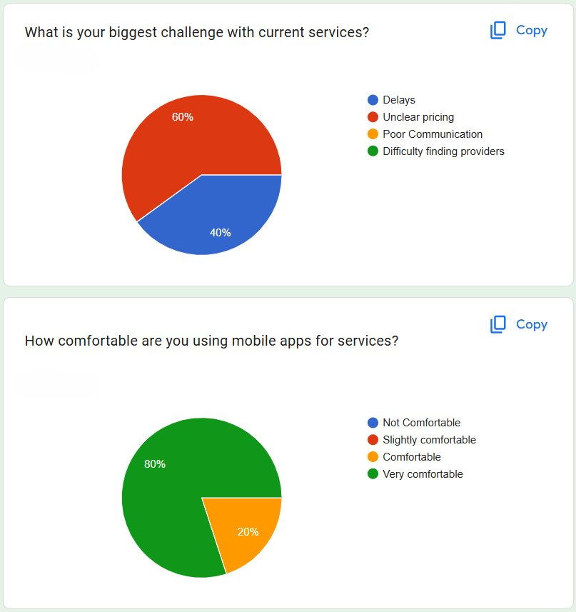
Figure 2 Biggest challenge with current services
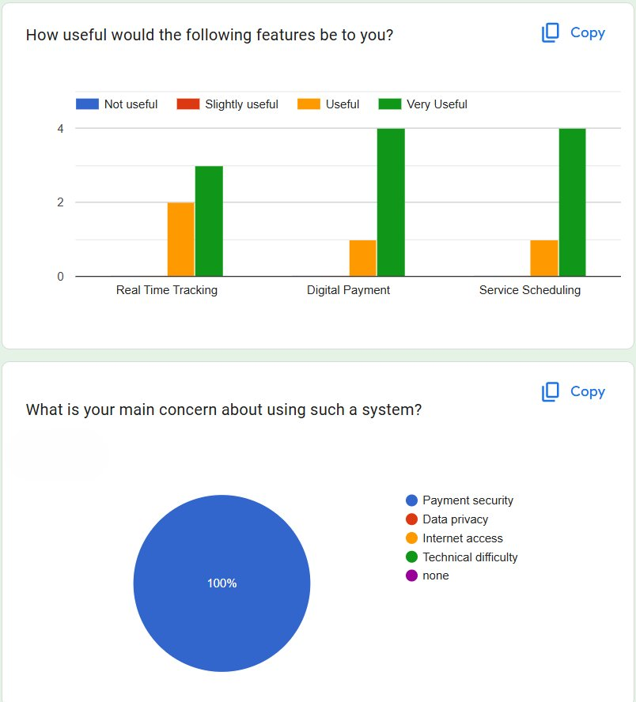
Figure 3Feature usefulness ratings and main system concerns.
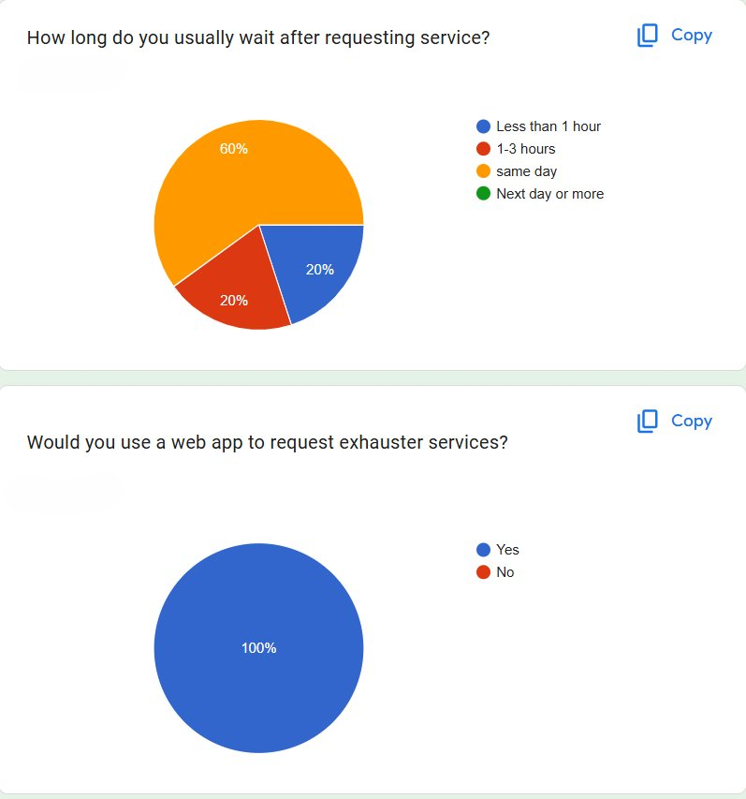
Figure 4Main concern about the proposed system.

Section 1 (cont.): Service Wait Times, App Adoption & Payment Preferences
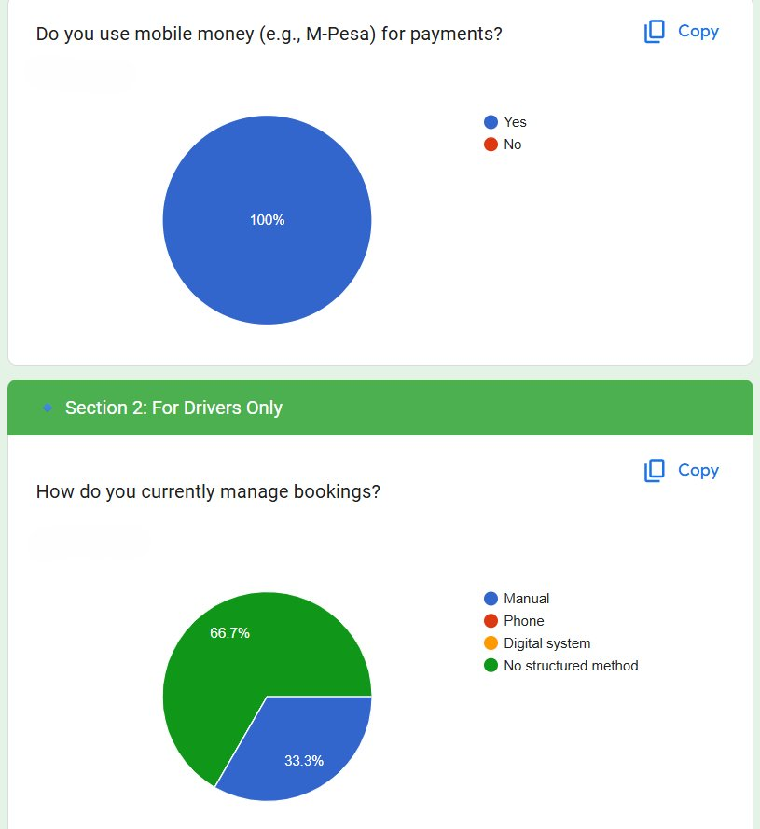
Figure 5M-Pesa usage and driver booking management methods.
Section 2: Driver Survey Results
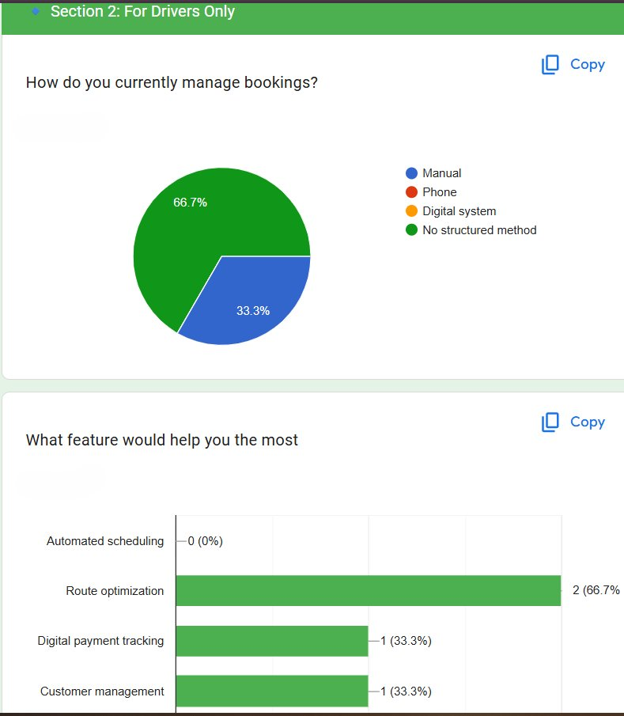
Figure 6Current booking management methods; most useful features for drivers
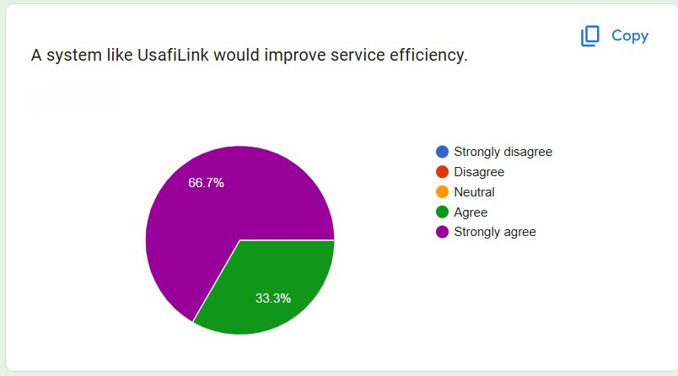
Figure 7driver perception of UsafiLink’s impact on service efficiency.

3.5.1 Analysis of Interview Responses
Interviews with an exhauster driver revealed that the current service coordination is entirely informal, relying on phone calls and word-of-mouth for job acquisition. Drivers report frequent route inefficiencies, payment disputes caused by cash-only transactions, and difficulty managing multiple job requests simultaneously. All interviewed drivers expressed strong interest in a digital platform providing structured job dispatch and digital payment collection.

3.5.2 Analysis of Questionnaire Responses

3.5.2.1 Current Methods of Exhauster Service Booking. Most customers rely on personal contacts or referrals to find exhauster services, with no standardised booking mechanism. This contributes to long search times and inconsistent pricing.

3.5.2.2 Challenges Faced During Service Coordination. The majority of respondents indicated unclear pricing and unpredictable wait times as the primary challenges. Service delays are compounded by the absence of a dispatch system, with customers often waiting over 30 minutes for a driver to confirm availability.

3.5.2.3 Expected Features in the Proposed System. Respondents indicated that the most important expected features are: automatic driver dispatch, M-Pesa payment integration, live driver tracking, transparent fare estimation, and SMS notifications for driver assignment.

3.5.3 Acceptance of the Proposed System. All five customer respondents and all three driver respondents expressed willingness to use a web-based exhauster service management system. Drivers prioritised digital payment collection and route efficiency tools, while customers emphasised transparent pricing and real-time driver tracking.

3.5.4 Conclusion
Through data analysis, significant limitations in the current informal exhauster service coordination process are confirmed. The proposed UsafiLink system addresses the identified challenges by providing automated proximity-based dispatch, transparent M-Pesa payment integration, and real-time driver tracking.

3.6 System Specification
The requirements of the proposed UsafiLink system are derived from data analysis findings. The requirements are categorised into functional and non-functional requirements.

3.6.1 Functional Requirements

FR No. | Module | Requirement
FR01 | Authentication | The system shall allow users to register using Email/Password, , or Google OAuth.
FR02 | Authentication | The system shall authenticate users and manage sessions using JWT access and refresh tokens.
FR03 | Authentication | The system shall send a one-time password (OTP) to the user's email address during registration.
FR04 | Authentication | The system shall support two-factor authentication (2FA) using a TOTP authenticator app.
FR05 | Service Request | The system shall automatically capture the customer's GPS coordinates upon service request submission.
FR06 | Dispatch | The system shall compute the Haversine distance between the customer's GPS coordinates and all available drivers and dispatch the nearest one automatically.
FR07 | Notifications | The system shall send an SMS notification to the assigned driver via Africa's Talking API.
FR08 | Dispatch | The system shall notify the assigned driver of a new job and allow accept or reject within a 10-second timeout enforced by Celery.
FR09 | Live Tracking | The system shall display the assigned driver's GPS location in real time, updated every 5 seconds during active jobs.
FR10 | Payment | The system shall initiate an M-Pesa STK Push payment prompt via the IntaSend API upon job completion.
FR11 | Payment | The system shall support IntaSend B2C payouts to disburse driver earnings to their registered M-Pesa number.
FR12 | Audit | The system shall maintain a transaction audit log recording all payment events, status changes, and M-Pesa callback responses.
FR13 | Driver Status | The system shall allow drivers to toggle their availability status, preventing dispatch to unavailable drivers.
FR14 | Ratings | The system shall allow customers to submit a star rating (1–5) for the driver upon job completion.
FR15 | Admin | The system shall allow the administrator to view all service requests, job assignments, completion records, and payment histories.
Table 3Functional Requirements – UsafiLink

3.6.2 Development Methodology Diagrams
Figure 3.2 – Scrum Sprint Schedule
The table below summarises the deliverables produced in each two-week sprint across the Agile development cycle.
Sprint | Deliverables
Sprint 1 (Weeks 1–2) | User authentication, Clerk & Google Auth integration, OTP, 2FA/TOTP setup
Sprint 2 (Weeks 3–4) | GPS service request module, proximity-matching dispatch algorithm, Celery driver timeout management, Africa’s Talking SMS alerts
Sprint 3 (Weeks 5–6) | IntaSend API for M-Pesa STK Push customer payments and driver payout integration
Sprint 4 (Weeks 7–8) | Driver rating system, transaction audit logging, administrative web dashboard
Sprint 5 (Weeks 9–10) | Integration testing, dispatch algorithm performance evaluation, user acceptance testing
Table 4: UsafiLink Scrum Sprint Schedule
Figure 3.3 – Project Gantt Chart
The Gantt chart below illustrates the planned schedule of all project activities across the eight-month development timeline.
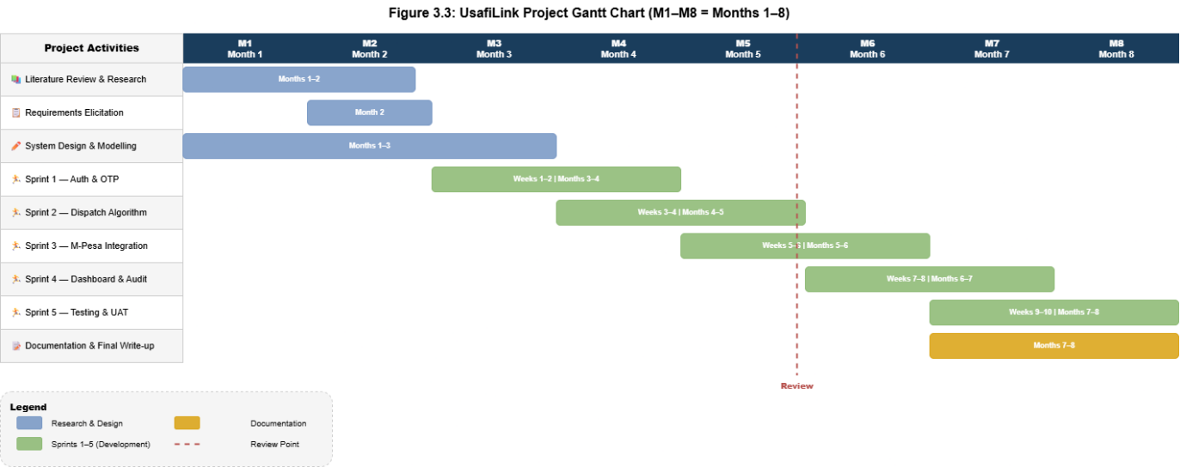
Figure 8UsafiLink Project Gantt Chart (M1–M8 = Months 1–8)

3.6.2 Non-Functional Requirements
Security Requirements
All API endpoints are secured via HTTPS and JWT bearer tokens. Passwords are stored as PBKDF2/bcrypt hashes. IntaSend callbacks are validated via IP whitelisting and payload signature verification.
Performance Requirements
The proximity dispatch algorithm shall compute and assign the nearest driver within 3 seconds of a service request. Driver GPS location updates shall synchronise to the server at intervals of no more than 5 seconds during active jobs.
Reliability Requirements
The backend API shall target an uptime of 99% during the pilot deployment period. Celery with Redis ensures asynchronous task reliability with retry mechanisms.
Scalability Requirements
The database schema shall accommodate growth in registered drivers and customers without structural changes. Celery worker processes shall be scalable horizontally.
Usability Requirements
The mobile web application shall be operable by a driver with basic smartphone literacy within a maximum of 3 taps to accept a job.
Maintainability Requirements
The use of modular Django REST Framework apps and well-documented API endpoints will facilitate future improvements and debugging.

3.6.3 System Users
- Customers – users who request exhauster services, make payments, and rate drivers.
- An exhauster driver – service providers who receive job assignments, navigate to customers, and collect digital payments.
- Administrators – responsible for monitoring fleet operations, managing driver records, and auditing financial transactions.

3.6.4 Conclusion
The system requirements outlined above provide a clear description of the expected functionalities and performance of UsafiLink, serving as the foundation for the system design and implementation phases.

3.7 Requirements Analysis and Modelling

3.7.1 Requirements Analysis
Requirements analysis involves examining system requirements to identify relationships, dependencies, constraints and possible solutions. Several issues were identified in the current informal exhauster service coordination process: absence of structured booking mechanisms, cash-only payment vulnerabilities, pricing opacity, and lack of proximity-based driver dispatch. UsafiLink addresses these by introducing a secure, automated and transparent service request and fulfilment platform.
Dependencies Identified:
- Authentication dependency – all system operations depend on successful user authentication via Clerk, Google OAuth, or Email/OTP.
- Dispatch dependency – the Haversine algorithm depends on drivers having current GPS coordinates and active availability status.
- Payment dependency – M-Pesa STK Push initiation depends on successful job completion confirmation by the driver.
- Audit dependency – transaction logging depends on successful IntaSend callback receipt and validation.
Proposed Solutions:
- Implement a simple and intuitive PWA interface optimised for mobile browsers.
- Use Celery asynchronous processing to minimise dispatch latency without blocking the main API thread.
- Provide clear feedback and error messages to guide users through the service request and payment flow.

3.7.2 Requirements Structuring
The requirements structuring is based on system users and their respective system functionalities.
Customer Functions:
- Register and securely log in via Google OAuth, or Email/OTP/2FA.
- Submit a GPS-tagged service request and receive automatic driver dispatch confirmation.
- Track the assigned driver in real time and complete payment via M-Pesa STK Push.
Driver Functions:
- Register with vehicle details, toggle availability status, and receive SMS/in-app job notifications.
- Accept or reject a job within 10 seconds, navigate to the customer, and mark the job complete.
Administrator Functions:
- Monitor active driver locations on a live fleet map and access job history and payment records.
System Functions:
- Compute Haversine distances and dispatch the nearest available driver.
- Enforce 10-second driver timeout via Celery and trigger M-Pesa STK Push on job completion.

3.7.3 Requirements Modelling
The system requirements were modelled using appropriate UML and analysis diagrams.

Use Case Diagram
The Use Case Diagram illustrates interactions between system actors (Customer, Exhauster Driver, Administrator) and secondary actors (Africa's Talking API, IntaSend API, Celery Worker, Google Maps API) and the UsafiLink system.
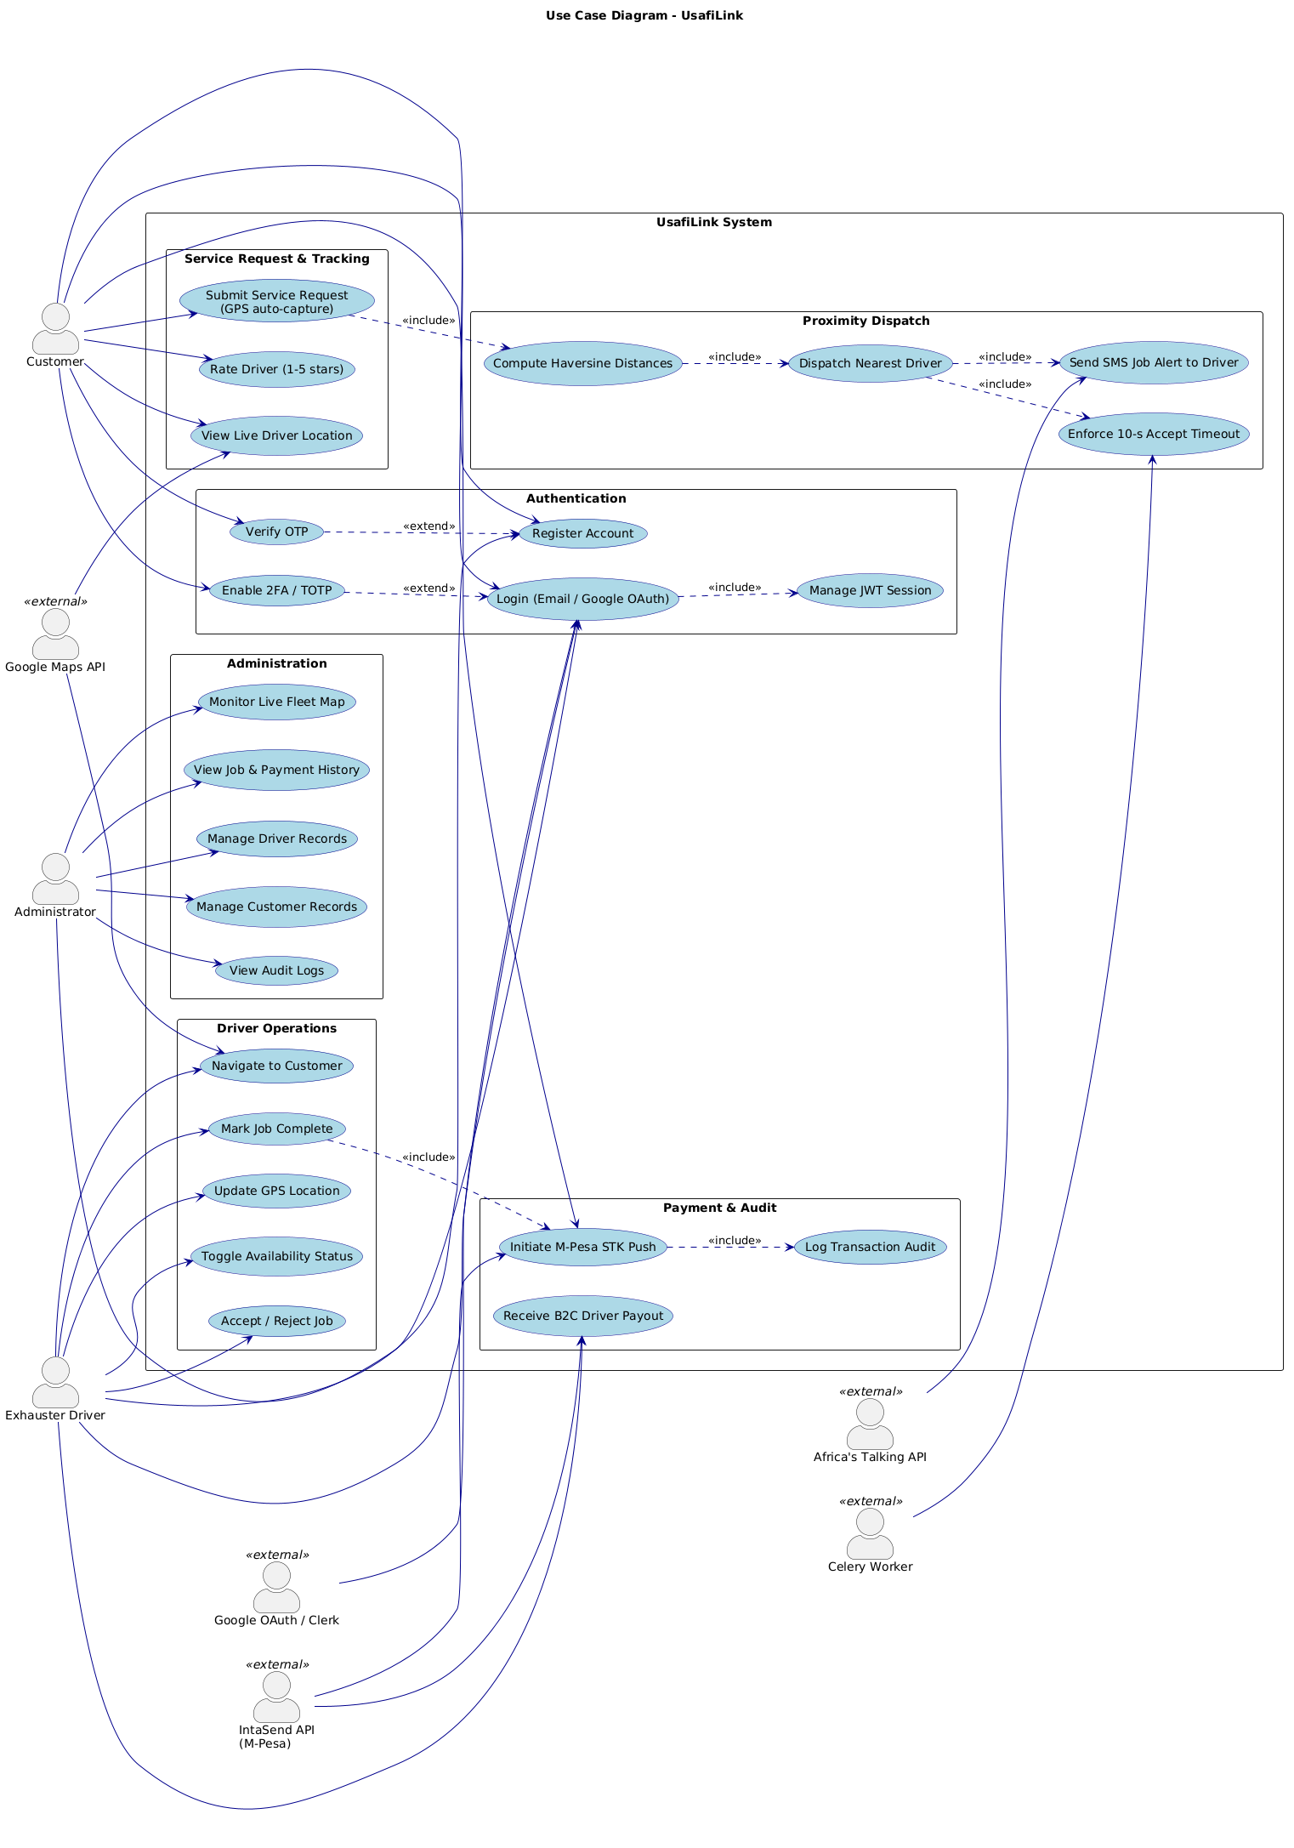
Figure 9: Use Case Diagram – UsafiLink

Data Flow Diagram
The Context-Level Data Flow Diagram (Level 0) illustrates the overall data flows between UsafiLink and its external entities: the Customer, the Exhauster Driver, the Administrator, IntaSend, Africa's Talking, and the Celery task broker.
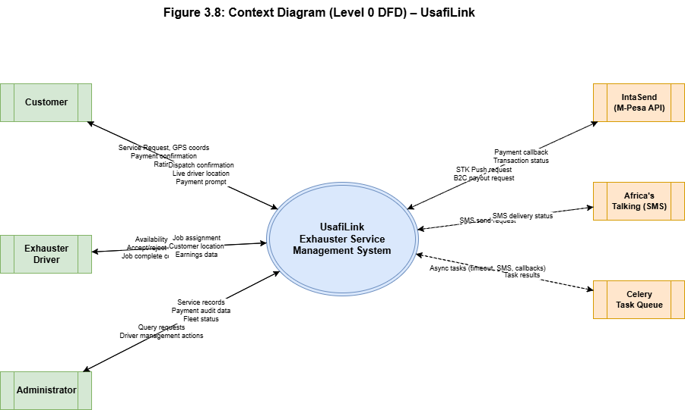
Figure 10: Context Diagram (Level 0 DFD) – UsafiLink

Level 1 Data Flow Diagram
The Level 1 DFD decomposes the system into its core processes: User Authentication, Service Request and Dispatch, Live Tracking, Payment Processing, and Audit Logging. It shows data flows between these processes and the underlying data stores: Users, Drivers, ServiceRequests, Jobs, Payments, and TransactionLogs.
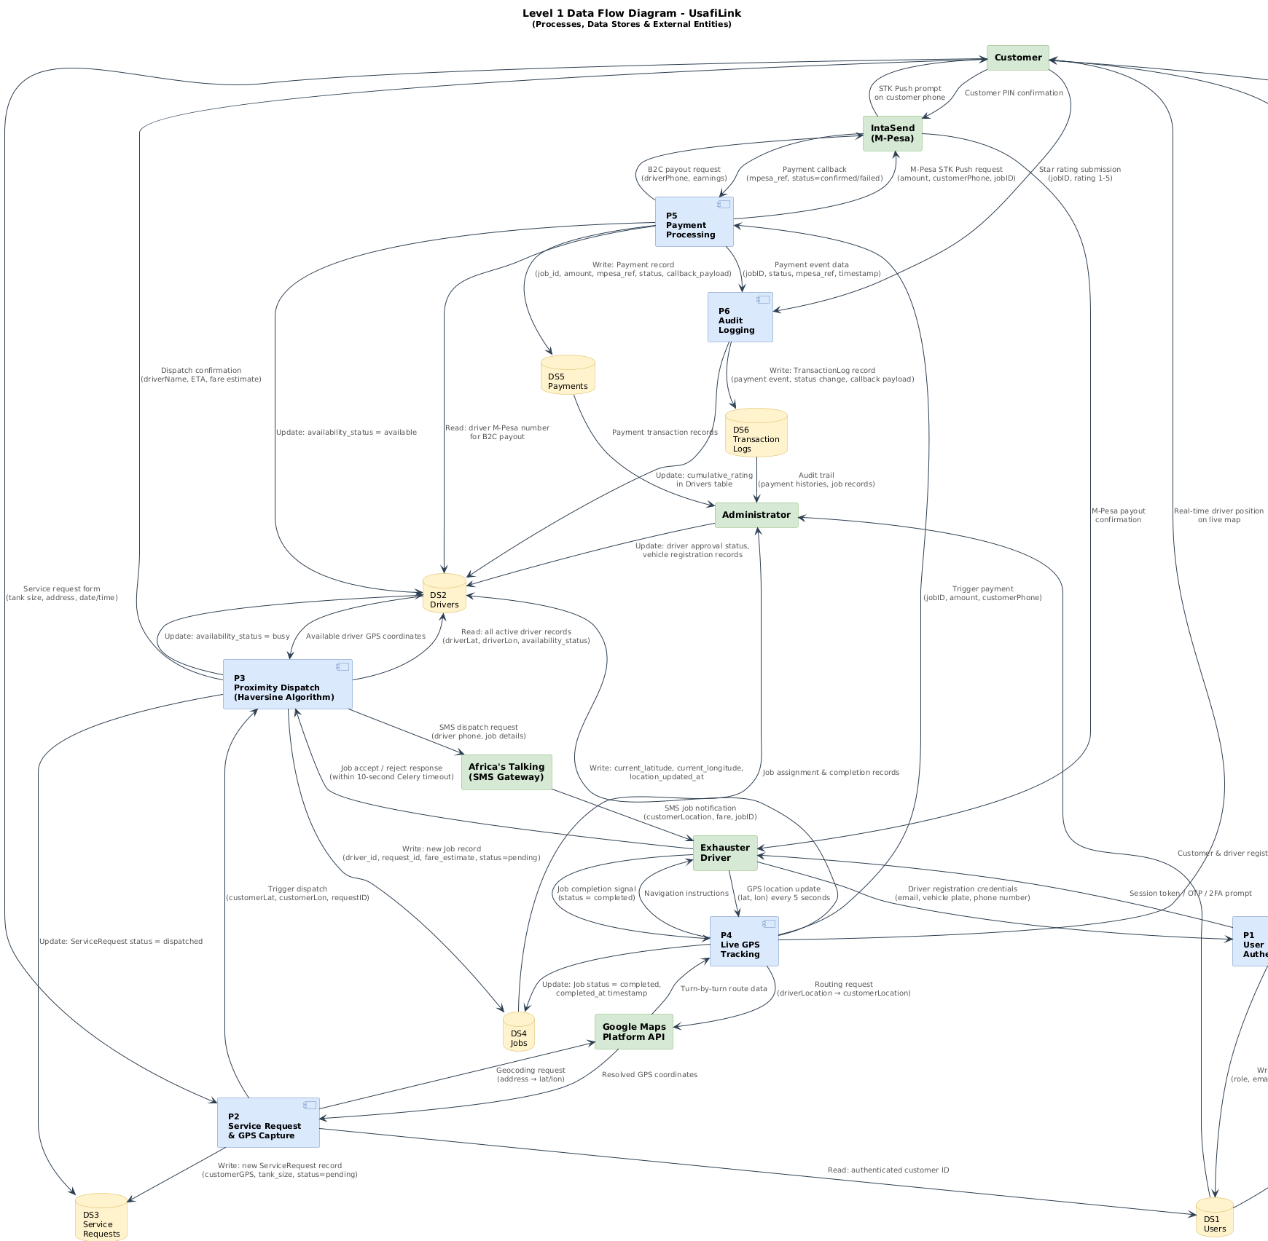
Figure 3.9: Level 1 Data Flow Diagram – UsafiLink

Class Diagram
The UML Class Diagram shows the core entity classes of UsafiLink, their attributes, key methods, and relationships. The primary classes are User, Driver (extends User), ServiceRequest, Job, Payment, Rating, DriverLocation, and TransactionLog.
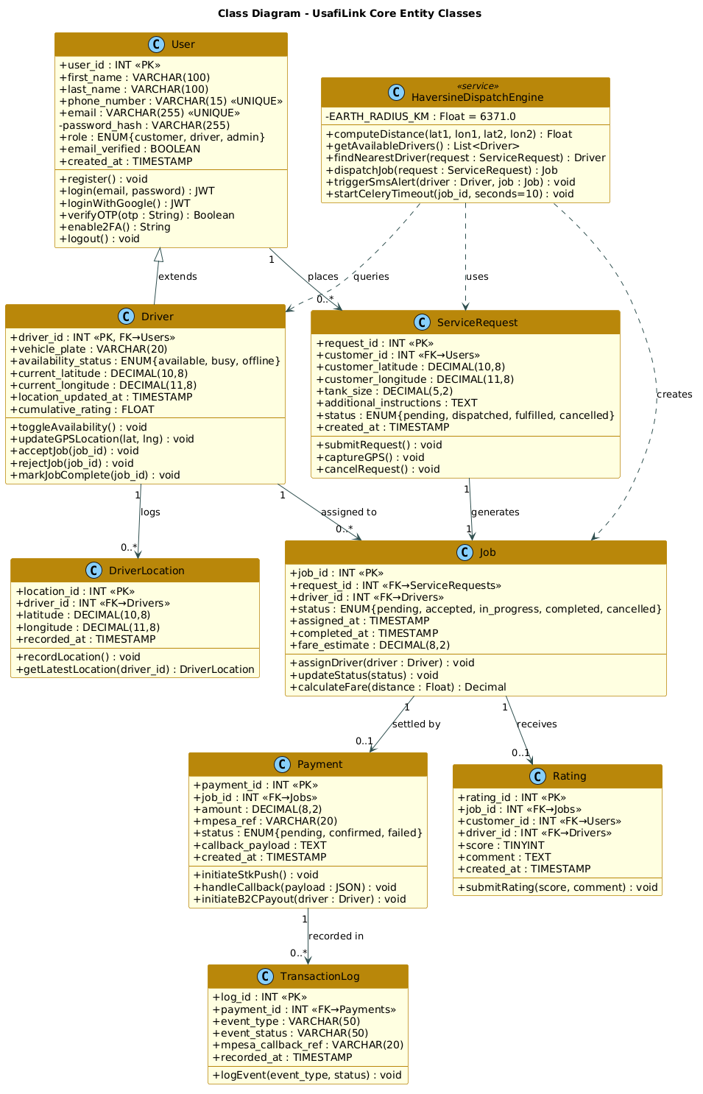
Figure 11Class Diagram – UsafiLink Core Entity Classes

3.8 Logical Design

3.8.1 System Architecture
UsafiLink follows a three-tier Client-Server architecture with a RESTful API middleware layer, clearly separating the presentation layer from the business logic layer and the data layer, making the system modular, testable and maintainable:
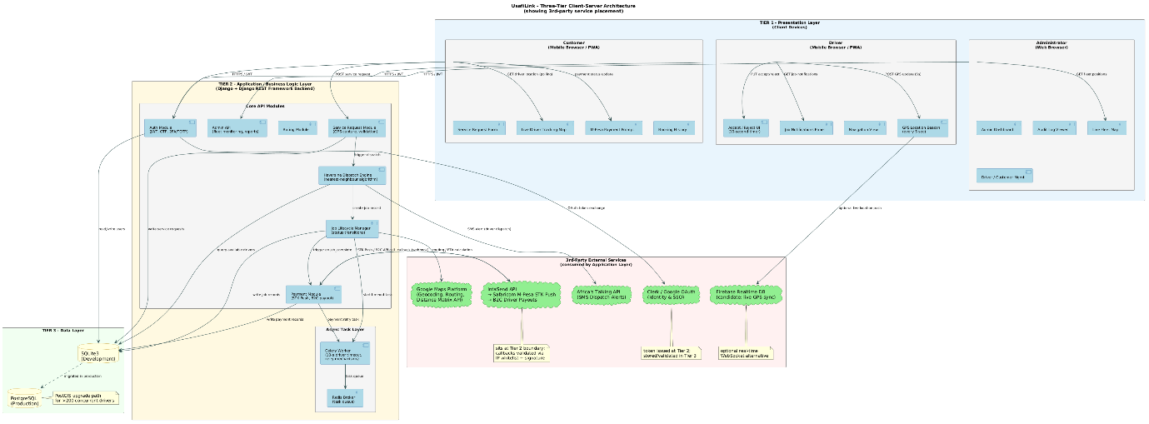
Figure 12UsafiLink Three-Tier Client-Server Architecture Diagram

3.8.2 Control Flow and Process Design
The core process flow centres on the service request and proximity dispatch cycle. When a customer submits a service request, the browser captures GPS coordinates via the HTML5 Geolocation API and transmits them to the Django backend. The Haversine algorithm queries available drivers, computes great-circle distances, and dispatches the nearest driver. An SMS notification is simultaneously triggered via Africa's Talking. A Celery task enforces the ten-second response timeout. Upon completion, an IntaSend M-Pesa STK Push is triggered, the audit log is updated, and the driver's status resets to available.

3.8.3 Structured English Description of Haversine Dispatch Algorithm:
BEGIN
RECEIVE serviceRequest from customer
GET customerGPS from request
GET allActiveDrivers from database
SET nearestDriver = NULL
SET minDistance = INFINITY

FOR EACH driver IN activeDrivers:
compute haversineDistance between customerGPS and driverGPS
IF haversineDistance < minDistance THEN
SET minDistance = haversineDistance
SET nearestDriver = driver
END IF
END FOR

IF nearestDriver IS NOT NULL THEN
ASSIGN job to nearestDriver
SEND SMS via Africa's Talking API
START Celery timeout task (10 seconds)
RETURN nearestDriver details to customer
ELSE
RETURN "No drivers available" to customer
END IF
END

3.8.4 Control Flow and Process Design
While Chapter 2 identified PostGIS as a scalable solution for server-side geospatial queries, UsafiLink implements the Haversine formula as an in-memory Python operation within the Django backend. This decision is justified for the pilot deployment scale (projected <50 active drivers), as it eliminates additional database extension dependencies and simplifies deployment. PostGIS remains a documented upgrade path for future scaling beyond 200 concurrent drivers.
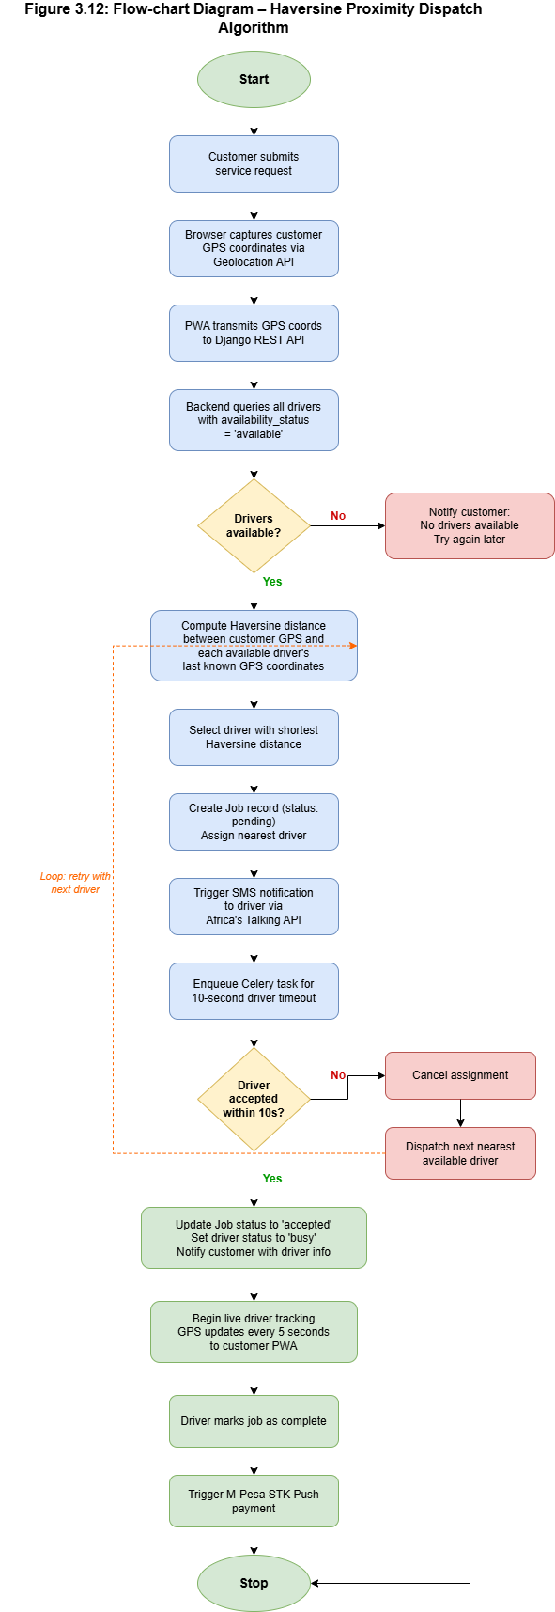
Figure 13Flow-chart Diagram – Haversine Proximity Dispatch Algorithm

3.8.5 Design of Non-Functional Requirements
- Security – all API endpoints are secured via HTTPS and JWT. Passwords are PBKDF2/bcrypt hashed. IntaSend callbacks validated via IP whitelisting.
- Performance – Haversine dispatch runs as an in-memory Python operation ensuring sub-3-second assignment. GPS polling is a lightweight GET request every 5 seconds.
- Reliability – Celery with Redis ensures asynchronous task reliability with retry mechanisms for failed SMS dispatches and payment callbacks.
- Scalability – stateless REST API design allows load balancing without session affinity.
3.9 Physical Design

3.9.1 Database Design
The UsafiLink SQLite development database is organised around eight core tables, designed in Third Normal Form (3NF) to eliminate data redundancy and ensure referential integrity.

Entity Relationship Diagram
The ERD below illustrates all entities, their primary and foreign key relationships, and cardinality notation.
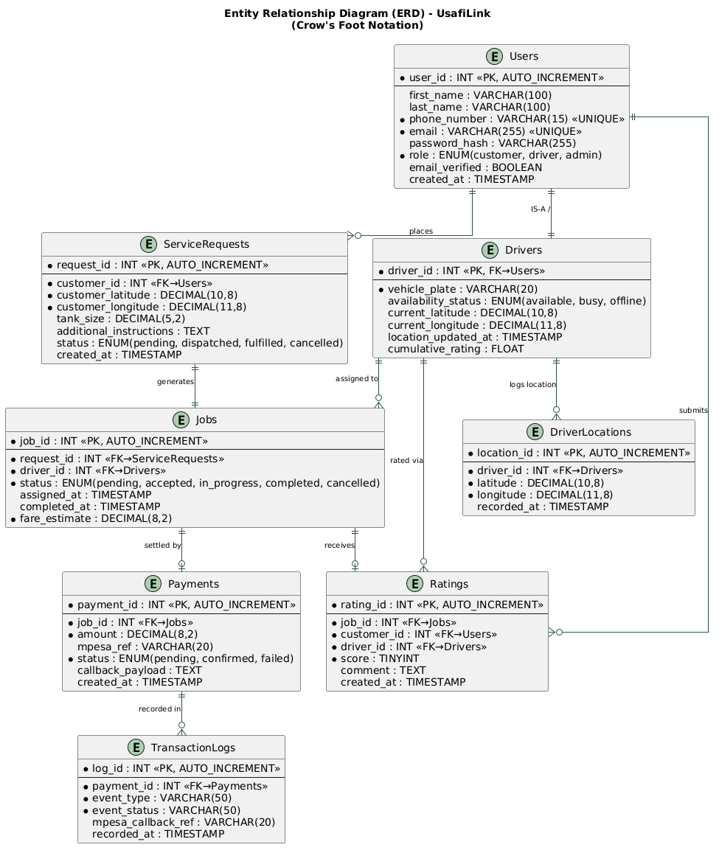
Figure 14Entity Relationship Diagram (ERD) – UsafiLink
The ERD above illustrates the relationships between core entities. A User can be a Customer or a Driver (specialized through the Drivers table). A Customer submits ServiceRequests, which generate Jobs assigned to a Driver. Each Job has one Payment, and each Job receives one Rating. The DriverLocation entity stores real-time GPS coordinates independent of the Drivers table to maintain location history. All relationships enforce referential integrity through foreign key constraints.

Logical Database Structure
The logical database structure for each core table is presented below.

Field | Data Type | Constraint | Description
user_id | INT | PK, AUTO_INCREMENT | Unique user identifier
first_name | VARCHAR(100) | NOT NULL | User's first name
last_name | VARCHAR(100) | NOT NULL | User's last name
phone_number | VARCHAR(15) | UNIQUE, NOT NULL | M-Pesa registered phone number
email | VARCHAR(255) | UNIQUE, NOT NULL | Email for OTP or SSO identity
password_hash | VARCHAR(255) | NOT NULL | PBKDF2 hashed password
role | ENUM(customer, driver, admin) | NOT NULL | User role for access control
email_verified | BOOLEAN | DEFAULT FALSE | Email OTP or OAuth verification status
created_at | TIMESTAMP | DEFAULT NOW() | Account creation timestamp
Table 5: Logical Database Structure – Users Table
Field | Data Type | Constraint | Description
driver_id | INT | PK, FK → Users | Links to Users table
vehicle_plate | VARCHAR(20) | NOT NULL | Exhauster truck registration plate
availability_status | ENUM(available, busy, offline) | DEFAULT 'offline' | Current driver availability
current_latitude | DECIMAL(10,8) | NULL | Last known GPS latitude
current_longitude | DECIMAL(11,8) | NULL | Last known GPS longitude
location_updated_at | TIMESTAMP | NULL | Timestamp of last GPS update
cumulative_rating | FLOAT | DEFAULT 0.0 | Average customer rating score
Table 6Logical Database Structure – Drivers Table

Field | Data Type | Constraint | Description
job_id | INT | PK, AUTO_INCREMENT | Unique job identifier
request_id | INT | FK → ServiceRequests | Linked service request
driver_id | INT | FK → Drivers | Assigned driver
status | ENUM(pending, accepted, in_progress, completed, cancelled) | NOT NULL | Current job lifecycle status
assigned_at | TIMESTAMP | NULL | Time driver was dispatched
completed_at | TIMESTAMP | NULL | Time job was marked complete
fare_estimate | DECIMAL(8,2) | NOT NULL | Calculated fare at time of dispatch
Table 7Logical Database Structure – Jobs Table
Field | Data Type | Constraint | Description
payment_id | INT | PK, AUTO_INCREMENT | Unique payment identifier
job_id | INT | FK → Jobs | Associated job
amount | DECIMAL(8,2) | NOT NULL | Payment amount (KES)
mpesa_ref | VARCHAR(20) | NULL | IntaSend/M-Pesa transaction reference
status | ENUM(pending, confirmed, failed) | NOT NULL | Payment confirmation status
callback_payload | TEXT | NULL | Raw IntaSend callback JSON
created_at | TIMESTAMP | DEFAULT NOW() | Payment initiation timestamp
Table 8: Logical Database Structure – Payments Table

3.9.2 User Interface Design
The user interface for UsafiLink is designed around three distinct user journeys: the Customer journey on the responsive Progressive Web Application, the Driver journey on the responsive PWA, and the Administrator journey on the Django-powered web dashboard. All interface designs were developed in Figma and represent the final UI design as deployed in the pilot.

Unauthenticated Users Pages
The Login Page (Figure 3.14) provides entry points for user authentication via Google OAuth, Email/Password, or magic link. It also links to the registration flow for new users.
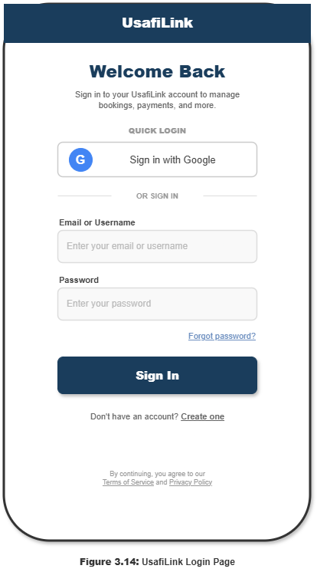
Figure 3.14 Illustration of the UsafiLink Login Page

Customer Pages
The Customer Dashboard (Figure 3.15) presents the user's booking statistics, upcoming bookings summary, quick action buttons for booking a new service, and a payment attention section. The driver tracking panel activates when a job is in progress.

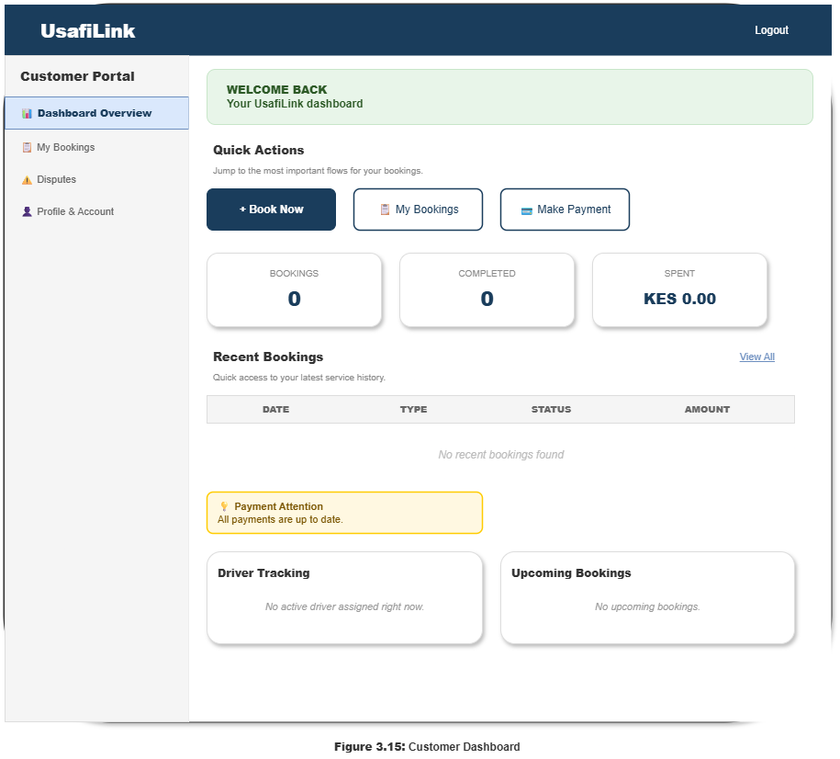
Figure 3.15 Illustration of the Customer Dashboard

The New Booking Form (Figure 3.16) guides the customer through scheduling an exhauster service in four steps: Location Details, Service Details, Date and Time Selection, and Additional Instructions. A live price estimate panel calculates the fare dynamically based on tank size and distance.

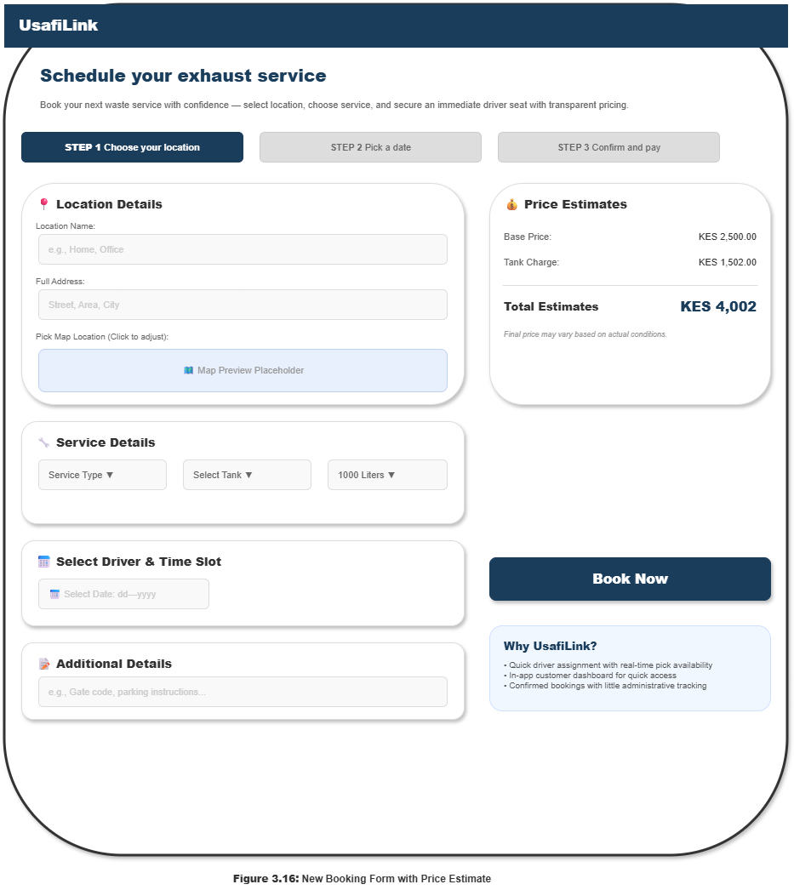
Figure 3.16 Illustration of the New Booking Form with Price Estimate

Driver Pages
The Driver Portal Dashboard (Figure 3.17) presents Today's Summary (jobs completed, earnings, hours worked), Today's Report (ratings and total earned), sections for Active Jobs, Assigned Jobs, Available Jobs, and a Performance Stats breakdown showing earnings per job type.

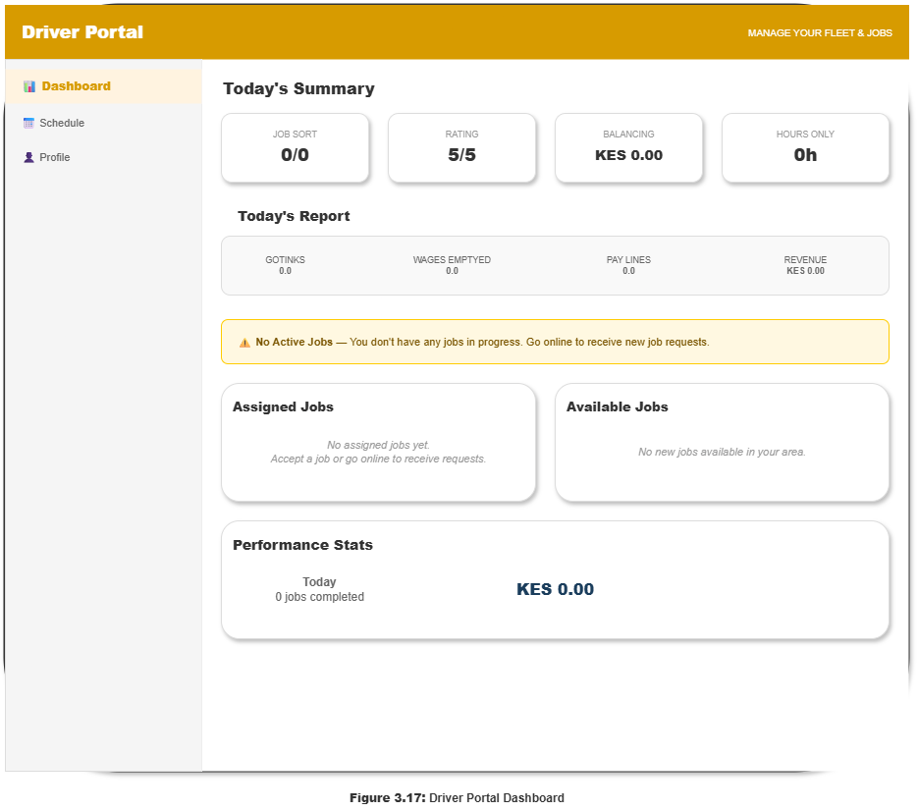
Figure 3.17 Illustration of the Driver Portal Dashboard

Admin Pages
The Admin Dashboard (Figure 3.18) provides a high-level operational overview including total revenue (KES), active drivers, pending driver approvals, average platform rating, pending bank transfers, weekly revenue trend chart, and a driver approvals panel.

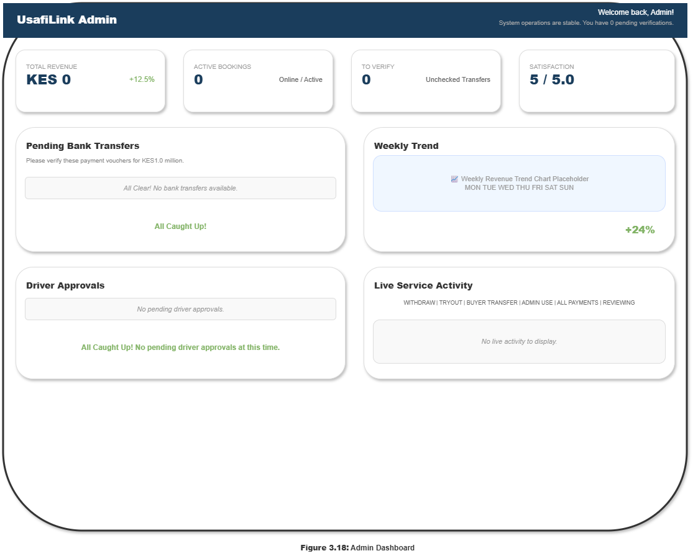
Figure 3.18 Illustration of the Admin Dashboard

The Admin Customer Management page (Figure 3.19) presents a filterable customer registry with total customer counts by status (Active, Inactive, Banned), searchable table with customer names, emails, status badges, and inline action buttons (View, Edit, Ban/Unban).

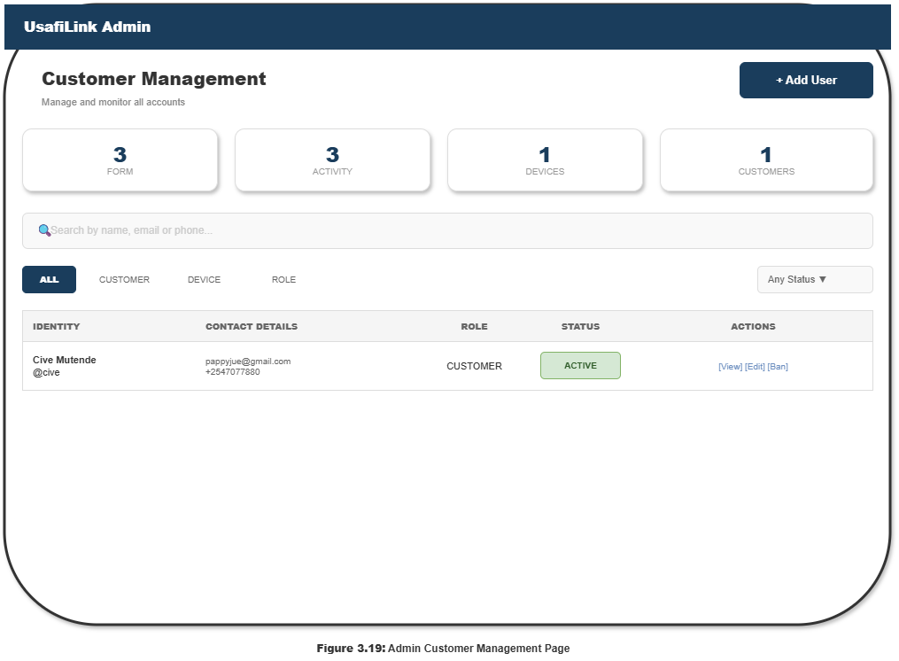
Figure 3.19: Illustration of the Admin Customer Management Page

The Admin Driver Management page with live map view (Figure 3.20) shows fleet statistics (total drivers, active, online), a live GPS map displaying driver positions, and a driver list panel beneath the map showing each driver's real-time availability status.

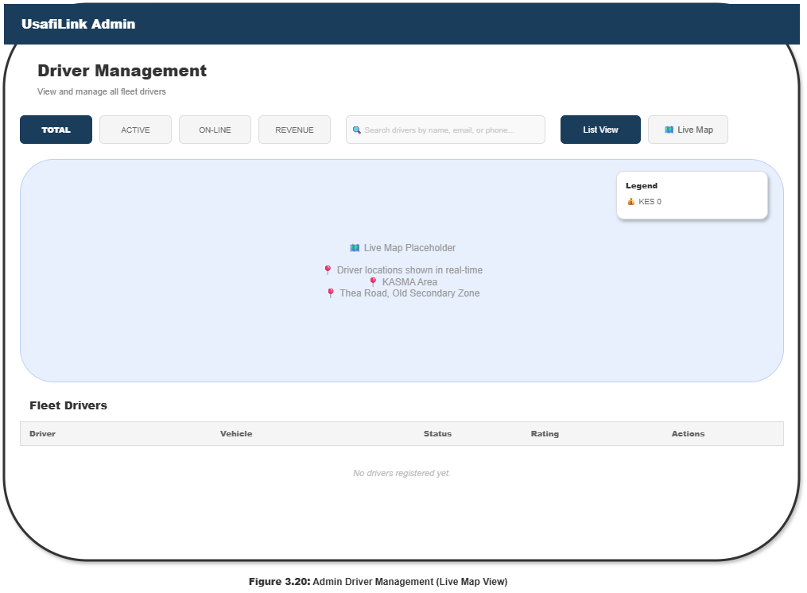
Figure 3.20: Illustration of the Admin Driver Management (Live Map View)

The Admin Fleet Management page (Figure 3.21) provides a vehicle-level registry showing each vehicle's registration plate, type, capacity (e.g., 9.0L), current status (Registration Approved / Pending), and associated driver details. Administrators can add new vehicles or update vehicle records from this page.

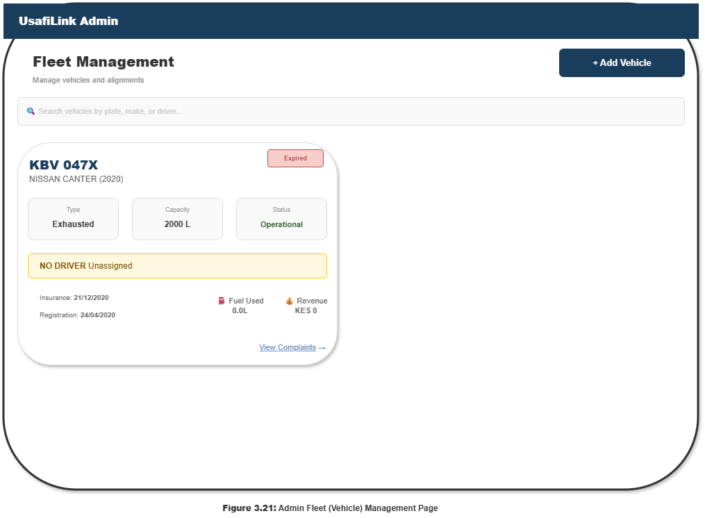
Figure 3.21 Illustration of the Admin Fleet (Vehicle) Management Page

REFERENCES
Chopde, N. R., & Nichat, M. K. (2013). Landmark based shortest path detection by using A* and Haversine formula. International Journal of Innovative Research in Computer and Communication Engineering, 1(2), 298–302.
Davis, F. D. (1989). Perceived usefulness, perceived ease of use, and user acceptance of information technology. MIS Quarterly, 13(3), 319–340. https://doi.org/10.2307/249008
Fielding, R. T. (2000). Architectural styles and the design of network-based software architectures (Doctoral dissertation, University of California, Irvine). https://www.ics.uci.edu/~fielding/pubs/dissertation/top.htm
Ghoseiri, K., & Ghannadpour, S. F. (2020). Real-time dispatch optimization for ride-hailing platforms using nearest-neighbour heuristics. Transportation Research Part C: Emerging Technologies, 112, 85–104. https://doi.org/10.1016/j.trc.2020.01.003
Google. (2023). Google Maps Platform documentation: Distance Matrix API. Google LLC. https://developers.google.com/maps/documentation/distance-matrix
IRC & Akvo. (2021). iWASH: Digital tools for urban sanitation services in Kampala. IRC WASH. https://www.ircwash.org
Kenya National Bureau of Statistics. (2022). Kenya housing and population census: Sanitation statistics. Government Printer.
Kenya National Environment Management Authority. (2021). State of the environment report 2021. NEMA Kenya.
Little Cab. (2022). About Little Cab: Technology and operations. https://www.littlecab.co.ke
Lwoga, E. T., & Lwoga, N. B. (2017). User acceptance of mobile payment systems in developing countries: The TAM perspective. The Electronic Library, 35(6), 1169–1192. https://doi.org/10.1108/EL-11-2016-0232
Moroney, L. (2017). The Firebase realtime database. In The Definitive Guide to Firebase (pp. 51–71). Apress. https://doi.org/10.1007/978-1-4842-2943-9_3
Obe, R., & Hsu, L. (2015). PostGIS in action (2nd ed.). Manning Publications.
Psaraftis, H. N., Wen, M., & Kontovas, C. A. (2016). Dynamic vehicle routing problems: Three decades and counting. Networks, 67(1), 3–31. https://doi.org/10.1002/net.21628
Safaricom. (2023). Daraja API documentation: M-Pesa STK Push. Safaricom PLC. https://developer.safaricom.co.ke
United Nations. (2023). World urbanization prospects 2023. Department of Economic and Social Affairs. https://population.un.org/wup/

